**Chapter 1**

**Introduction**

Air is one of the essential elements of man’s surroundings. The earth’s atmosphere is full of air which contains gases such as Nitrogen, Oxygen, Carbon Monoxide and traces of some rare elements. Humans need an atmosphere of air that is free from contaminants. This is very crucial for human life and health. Any change in the natural composition of air may cause grave harm to life forms on earth. Air pollution is the presence of one or more contaminants in the atmosphere such as gases in a quantity that can harm humans, animals and plant.

* 1. **Background:**

Air pollution affects our day to day activities and quality of life. It poses a threat to the ecosystem and the quality of life on the planet. The dire need to monitor air quality is very glaring, owing to increased industrial activities over the past years. People need to know the extent to which their activities affect air quality. This project proposes an air pollution monitoring system. The system was developed using the Arduino microcontroller. The air pollution monitoring system was designed to monitor and analyze air quality in real-time and log data to a remote server, keeping the data updated over the internet. Air quality measurements were taken based on the Parts per Million (PPM) metrics and analyzed using Microsoft Excel. The air quality measurements taken by the designed system was accurate.

* 1. **Objective :**
* provide comprehensive data to judge the significance of actual and perceived regional issues
* be related to the issues, objectives and methods of implementation specified in the regional air plan
* supply sufficient data to determine geographical patterns in air quality over various time scales (eg, seasonally)
* lead to an understanding of whether national or regional air quality standards, guidelines, objectives and environmental outcomes are being met, and whether areas of concern are being identified
* develop a picture of representative concentrations in areas of high population density where air quality is known, or suspected, to be poor
* provide sufficient data to determine trends in air quality over time and the background levels of contaminants
* supply enough information to determine the population at risk from exposure to poor air quality in order to evaluate the potential and actual health effects in a region (eg, personal exposure assessments).

**1.3 Purpose, Scope , Applicability:**

**1.3.1 Purpose:**

* The primary purpose of a systematic air quality monitoring network is to distinguish between areas where [pollutant](https://www.sciencedirect.com/topics/earth-and-planetary-sciences/contaminant) levels violate an [ambient air](https://www.sciencedirect.com/topics/earth-and-planetary-sciences/ambient-air) quality standard and areas where they do not.
* Understand the working principles and functions of each component used.
* Assembling and connecting the circuit to the Arduino Uno.
* A systematic monitoring network is to document the success of this sophisticated endeavor, either to record the rate of progress towards attaining the ambient air quality standard or to show that the standard has been achieved.

**1.3.2 Scope:**

* Project is based on automation technology we tried our best to implement all the possible mechanism for that.
* This project has numerous potential and may be used in various other ways due to its cheap and cost efficient design.

**1.3.3 Applicability:**

* Air pollution monitoring system is application that can be used check the quality of the air. This project will almost all the process involved in daily routine.
* With the use of IOT technology enhances the process of monitoring various aspects of environment such as air quality monitoring issue

**Chapter 2**

**Survey of Technologies**

**The tools we using for software are :**

**Arduino IDE :**

The Arduino integrated development environment (IDE) is a cross platform application ( for Windows, macOS, Linux) that is written in the programming language Java. It is used to write and upload programs to Arduino compatible boards, but also, with the help of 3rd party cores, other vendor development boards. The source code for the IDE is released under the GNU General Public License, version 2. The Arduino IDE supports the languages C and C++ using special rules of code structuring. The Arduino IDE supplies a software library from the Wiring project, which provides many common input and output procedures. User - written code only requires two basic functions, for starting the sketch and the main program loop, that are compiled and linked with a program stub main() into an executable cyclic executive program with the GNU toolchain, also included with the IDE distribution. The Arduino IDE employs the program avrdude to convert the executable code into a text file in hexadecimal encoding that is loaded into the Arduino board by a loader program in the board's firmware.

**Technology that we have used in our project are as follows :**

**C++**

C++ is a general- purpose programming language created by Bjarne Stroustrup as an extension of the C programming language, or " C with Classes" . The language has expanded significantly over time, and modern C++ has object- oriented, generic, and functional features in addition to facilities for low- level memory manipulation. It is almost always implemented as a compiled language, and many vendors provide C++ compiler s, including the Free Software Foundation, LLVM, Microsoft, Intel, and IBM, so it is available on many platforms.

**Chapter 3**

**Requirement Analysis**

**3.1 Problem Definition :**

1.Perfect choice of component to make a project.

2.Lack of information about the iot based air pollution monitoring system on the internet.

3.Component is not easily available and they are expensive.

4.Proper maintenance is required.

**3.2 Requirement Specification:**

System requirement specification gives the complete description of the behaviour about the system developed by this project. This includes specification of functional and non-functional requirements of the project.

**3.2.1 Functional requirement:**

Functional requirements record the operation that must be done. Functional requirements are based for non-functional requirements.

**3.2.2 Non-functional requirements:**

The non-functional requirements defines how the system will do certain operation. Non-functional requirements usually called as “quality attributes”. The system should also meet along with the functional requirements.

**•Hardware interface:**

Hardware interface is a physical binding which connects the people and technology. The system will collaborate with the hardware resources. It disciplines the design which shapes the connection between user and the technology.

**•Software interface:**

Software interfaces provides access to resources such as memory storage,cpu.etc of the system.

**•Performance interface:**

The performance of the software may be hinder due to various causes.

**3.3 Planning and Scheduling :**

**Gantt Chart :**

**Pert Chart :**

**3.4 Software And Hardware Requirements:**

SOFTWARE REQUIREMENTS

* Arduino IDE

HARDWARE REQUIREMENTS

* MQ135 Gas sensor
* Arduino Uno
* Wi-Fi module ESP8266
* 16X2 LCD
* Breadboard
* 10K potentiometer
* 1K ohm resistors
* 220 ohm resistor
* Buzzer

**3.5 Preliminary product Description :**

In this project we are going to make an **IOT Based Air Pollution Monitoring System** in which we will **monitor the Air Quality over a webserver using internet** and will trigger a alarm when the air quality goes down beyond a certain level, means when there are sufficient amount of harmful gases are present in the air like CO2, smoke, alcohol, benzene and NH3. It will show the air quality in PPM on the LCD and as well as on webpage so that we can monitor it very easily.

## 3.6 Conceptual Models :

### 3.6.1 Block Diagram:

## 

**ARDUINO**

**UNO**

**16 X 2**

**DISPLAY**

**MQ135 SENSOR**

### 

**ESP8266**

**WI-FI**

**POWER**

**SUPPLY**

Block diagram is a graphical representation of a system – it provides a functional view of a system. Block diagrams give us a better understanding of a system’s functions and help create interconnections within it. Block diagrams derive their name from the rectangular elements found in this type of diagram. They are used to describe hardware and software systems as well as to represent processes. Block diagrams are described and defined according to their function and structure as well as their relationship with other blocks.

### 3.6.2 Data Flow diagram:

**Air quality detector**

**Read air quality**

**Display reading**

**Compare reading**

Not matches

**Blow buzzer**

A data flow diagram (DFD) maps out the flow of information for any process or system. It uses defined symbols like rectangles, circles and arrows, plus short text labels, to show data inputs, outputs, storage points and the routes between each destination. Data flowcharts can range from simple, even hand-drawn process overviews, to in-depth, multilevel DFDs that dig progressively deeper into how the data is handled. They can be used to analyze an existing system or model a new one. Like all the best diagrams and charts, a DFD can often visually “say” things that would be hard to explain in words

**3.6.3 Circuit Diagram:**

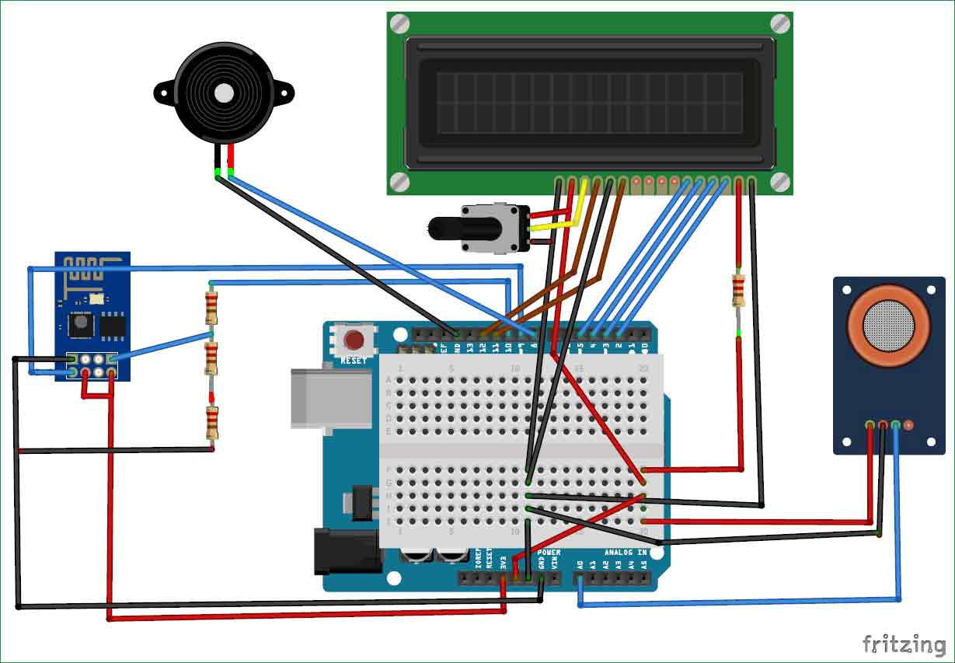

A circuit diagram (also known as an electrical diagram, elementary diagram, or electronic schematic) is a simplified conventional graphical representation of an electrical circuit. A pictorial circuit diagram uses simple images of components, while a schematic diagram shows the components of the circuit as simplified standard symbols; both types show the connections between the devices, including power and signal connections. Arrangement of the components interconnections on the diagram does not correspond to their physical locations in the finished device.

Unlike a block diagram or layout diagram, a circuit diagram shows the actual wire connections being used. The diagram does not show the physical arrangement of components. A drawing meant to depict what the physical arrangement of the wires and the components they connect is called "artwork" or "layout" or the "physical design."

Circuit diagrams are used for the design (circuit design), construction (such as PCB layout), and maintenance of electrical and electronic equipment

### 3.6.4 Component Diagram:

**3.6.4.1 Arduino Uno:**

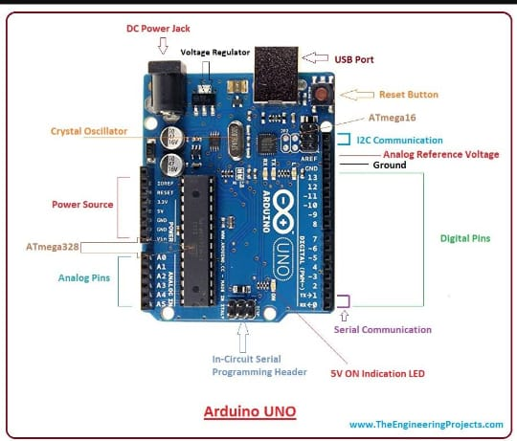

The Arduino Uno is an open source microcontroller board based on the microchip ATmega 328p microcontroller and developed by Arduino. c. c. The board is equipped with sets of digital and analog input or output pins that may be interfaced to various expansion boards and other circuits. The board has 16 digital pins, 6 analog pins, and programmable with the Arduino IDE( Integrated Development Environment) via a type B USB cable. It can be powered by the USB cable or by an external 9 volt battery.

**3.6.4.2 MQ135 Gas sensor:**

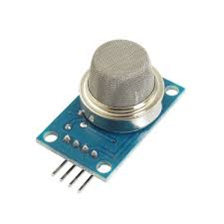

When it comes to measuring or detecting a particular Gas the MQ series Gas sensors are the most inexpensive and commonly used ones. **MQ135** is available as a module or as just the sensor alone. If you are trying to only detect (not measuring PPM) the presence of a gas then you can buy it as a module since it comes with an op-amp comparator and a digital output pin. But if you planning to measure the PPM of a gas it is recommend buying the sensor alone without module.

**3.6.4.3 ESP8266 wi-fi module:**

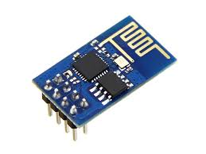

The **ESP8266**is a very user friendly and low cost device to provide internet connectivity to your projects. The module can work both as a Access point (can create hotspot) and as a station (can connect to Wi-Fi), hence it can easily fetch data and upload it to the internet making **Internet of Things** as easy as possible. It can also fetch data from internet using API’s hence your project could access any information that is available in the internet, thus making it smarter. Another exciting feature of this module is that it can be programmed using the Arduino IDE which makes it a lot more user friendly.

**3.6.4.4 16x2 lcd display:**

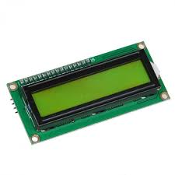

LCD modules are vey commonly used in most embedded projects, the reason being its cheap price, availability and programmer friendly. Most of us would have come across these displays in our day to day life, either at PCO’s or calculators**16×2 LCD** is named so because; it has 16 Columns and 2 Rows.

**3.6.4.5 Breadboard:**

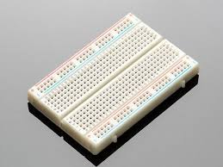

A breadboard is a solderless device for temporary prototype with electronics and test circuit designs. Most electronic components in electronic circuits can be interconnected by inserting their leads or terminals into the holes and then making connections through wires where appropriate. The breadboard has strips of metal underneath the board and connect the holes on the top of the board

**3.6.4.6 Buzzer:**

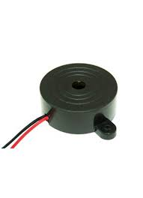

A **buzzer**is a small yet efficient component to add sound features to our project/system. It is very small and compact 2-pin structure hence can be easily used on breadboard, Perf Board and even on PCBs which makes this a widely used component in most electronic applications.

**Chapter 4**

**System Design**

**4.1 Basic Module:**

**4.1.1 Arduino Uno:**

The Arduino Uno is the microcontroller. Arduino uno is the main module in this project. It takes input and gives output to the sensor and hardware. Arduino Uno takes the all inputs from sensors and gives output.

**4.1.2 MQ135 Gas sensor:**

The MQ-135 Gas sensors are used in air quality control equipments and are suitable for detecting or measuring of NH3, NOx, Alcohol, Benzene, Smoke, CO2.

**4.1.3 buzzer:**

This buzzer can be used by simply powering it using a DC power supply ranging from 4V to 9V. A simple 9V battery can also be used, but it is recommended to use a regulated +5V or +6V DC supply. The buzzer is normally associated with a switching circuit to turn ON or turn OFF the buzzer at required time and require interval.

**4.1.2 16 x 2 lcd display:**

LCD modules are vey commonly used in most embedded projects, the reason being its cheap price, availability and programmer friendly.

**4.2 Security Issues:**

Security is the most important aspects of any IoT project. It is the feature of the system which ensures that system must be protected from the unintentional or malignant harm.